802.1X
802.1X
802.1X
DLP Storage Sensor
Firewall
DLP
Agent
DLP
Agent
Firewall
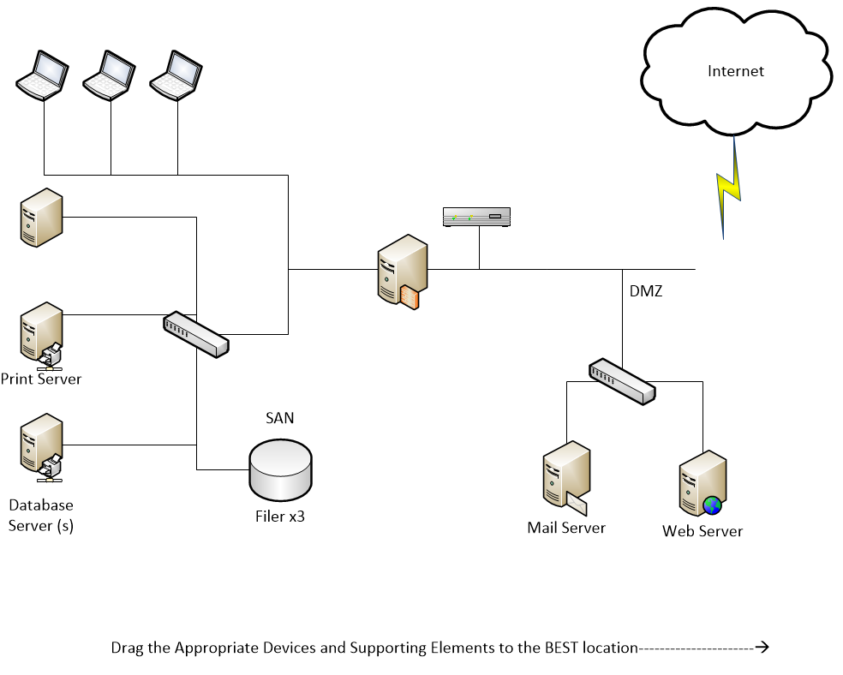
NIPS
Switch
Switch
DLP Server
NIPS
Switch
Router
Proxy Server
DLP
Network Sensor
DLP
Agent
HIDS
HIDS
HIDS
HIDS
HIDS
HIDS
HIDS
HIDS
HIDS
HIDS
Antivirus
Antivirus
Antivirus
Antivirus
Antivirus
Antivirus
Antivirus
Antivirus
Antivirus

